**Project S**

This is a game that mashes up the 8 bit world with the modern 16 bit world where the person is interacting with the real world. I have no idea on how to name such game that’s what I thought in mind.

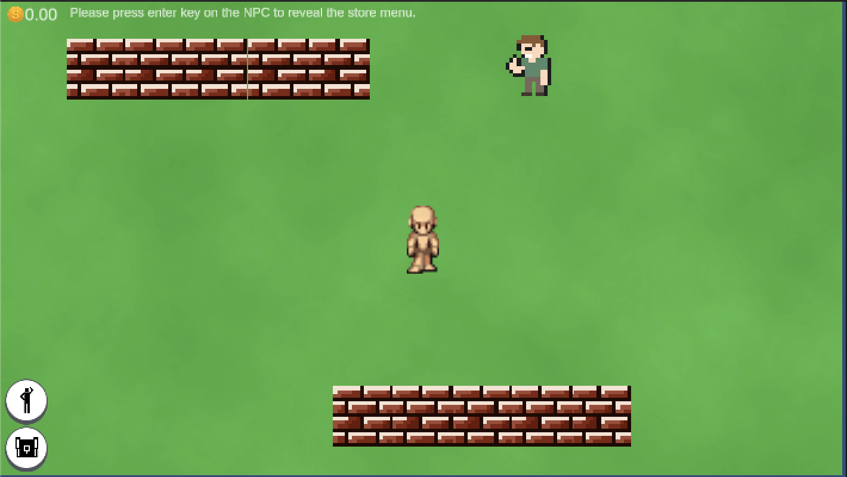

There will be basic UI interface where you’ll see the player with an NPC who acts like a shopkeeper where you’ll have to interact with. In order to interact with the shopkeeper, You have to press the enter button so that you’ll be able to see open the buy and sell menu. Please note that it’s still not yet working as of now.

The basic interaction are the box colliders are implemented so that there will be limits within the game world.

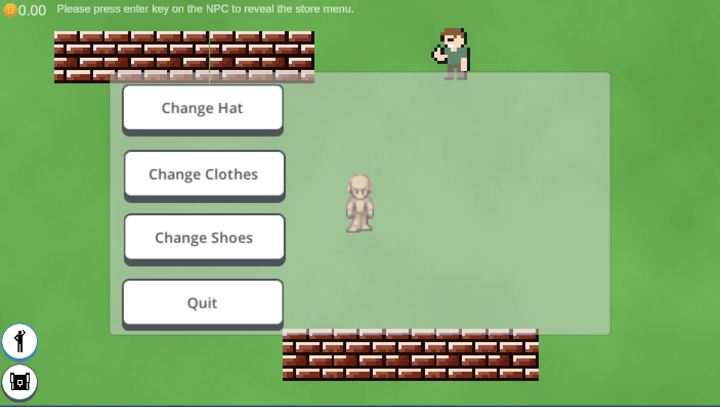

This is the character customization view (still under construction) for now. This is where the customization of the player will take place. You’ll be able to customize the hat, clothes and the shoes that the player is wearing.

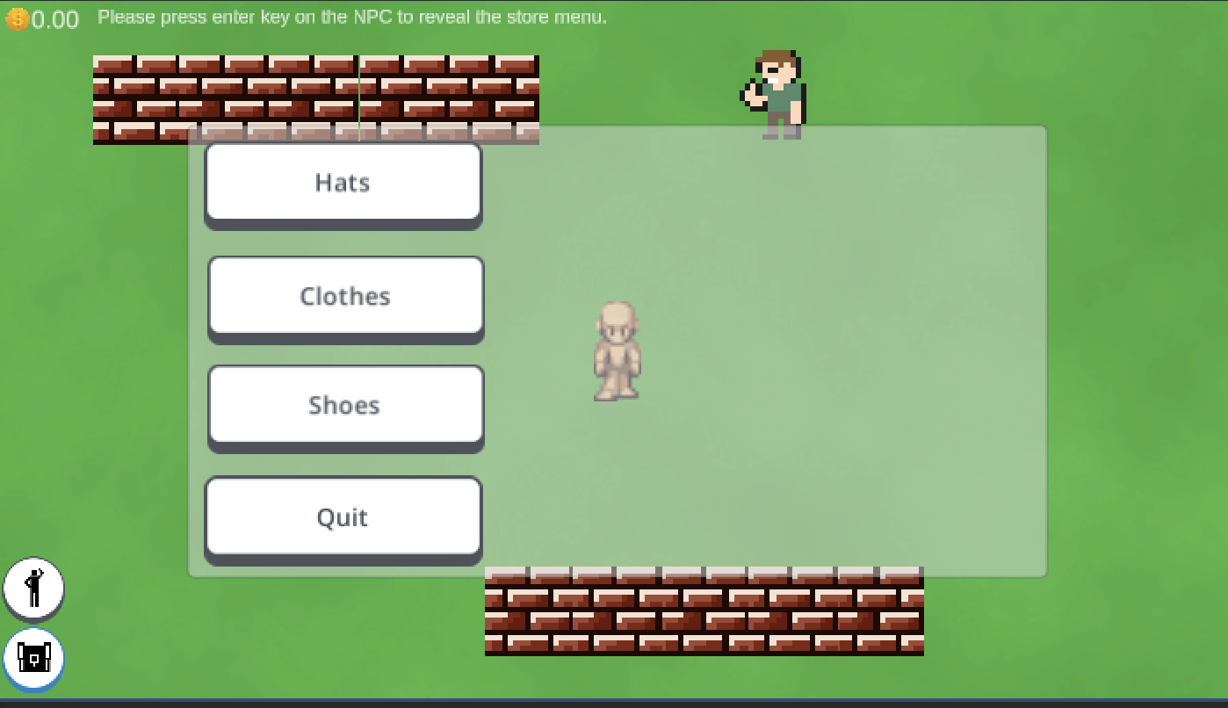

This is the inventory menu (under construction). This is where all the hats, clothes and the shoes of the player character will be stored in the game.

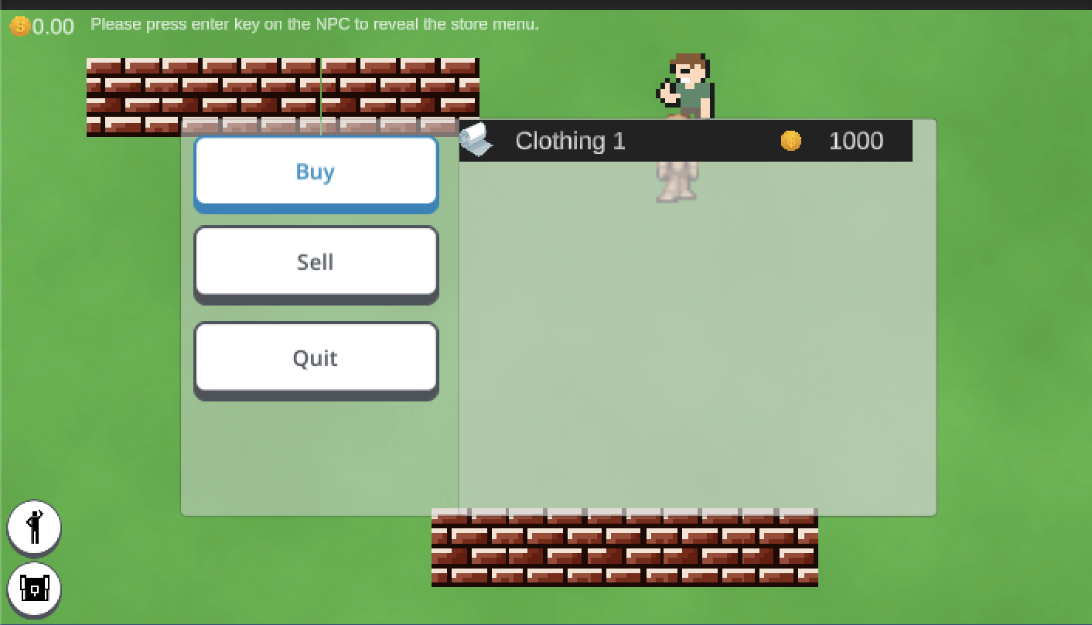

This is the store interface where the player will be able to buy clothing and sell all the clothing of the player in the inventory of the player. The description of the clothing and the price is displayed in a templated form. Please note that this is a template and the functionality is still under construction.

**Thought Process**

When it comes to the structure. I even have to organize all the scripts, sounds, graphics in separate folders each.

This is my hierarchy structure in the scene file.

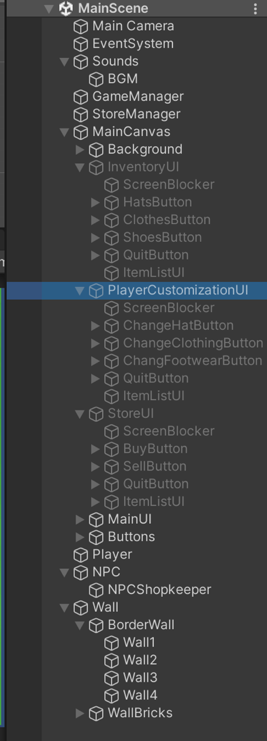

This is how I structured my scene in the game.

**Self-Performance assessment**

As for my performance assessment, I would only rate myself only 5 or 6/10 because I have experienced complications implementing the feature due my first time coding an complicated feature with a short timeframe due to my experience only with working with hypercasual games. I find it challenging due to the time constraints especially that designing the UI is consuming a lot of time for me because design and creativity is one of my Achilles’ heel with having little time to do the programming side of things. I tend to lean more in programming side of things.